**INDEX**

|  |  |  |
| --- | --- | --- |
| **Serial No.** | **Title** | **Page No.** |
| **1.** | **Introduction** | **2** |
| **2.** | **Challenge** | **2** |
| **3.** | **Vision** | **2-3** |
| **4.** | **Mission** | **3** |
| **5.** | **SWOT Analysis** | **3-6** |
| **6.** | **Vision Visual** | **6** |
| **7.** | **Data Pipeline** | **6-7** |
| **8.** | **Cloud Architecture** | **8** |
| **9.** | **Conclusion** | **8-9** |

**Introduction**:

Leading Canadian budget store chain Dollarama has incorporated contemporary technologies to improve business processes and consumer satisfaction. All of the merchandise at the stores is priced at $4 or less, and it includes toys, party supplies, office supplies, household goods, and seasonal merchandise. With its tech-driven strategy, Dollarama uses technology to boost customer satisfaction, increase efficiency, and improve a number of operational factors.

With an emphasis on providing a large selection of commonplace items at reasonable costs, Dollarama operates on a low-cost, high-volume business model. Even though Dollarama is well-established in Canada, growth may be aided by entering new areas or markets. This can entail entering foreign markets or setting up shop in underserved locations.

**Challenges**:

In order to effectively manage inventory, automate reordering, and make wise decisions, Dollarama must overcome a number of obstacles. Among these difficulties are the following:

1. **Inventory Complexity**: A variety of products are available at Dollarama, each with a unique shelf life and demand patterns. It takes advanced inventory management systems and procedures to handle such a diverse inventory.

2. **Demand Forecasting**: Accurately estimating customer demand is difficult, particularly for products that are driven by trends or seasonality. Erroneous demand projections may result in stockouts or overstocking.

3. **Supply Chain Disruptions**: Supply chain disruptions, such as shipments being delayed or supplier pricing fluctuating, have an effect on Dollarama's inventory management. The availability and price of products may be impacted by these disruptions.

4. **Data Integration**: Bringing together data from multiple sources, including supplier information, sales transactions, and inventory levels, into a single system for analysis and decision-making presents hurdles for Dollarama.

5. **Automation**: Although Dollarama wants to automate reordering procedures, doing so is difficult and necessitates a large investment in both technology and manpower.

6. **Decision-Making**: Relying on data analytics to make educated choices necessitates the use of strong data analytics technologies and knowledgeable staff. Making sure decision-makers have access to timely and reliable data is a challenge for Dollarama.

7. **Competition**: Given how fiercely competitive the retail sector is, Dollarama's inventory management procedures need to be up to date with rivals who are also making significant investments in cutting-edge techniques and technologies.

**Vision**

The goal of Dollarama's vision is to minimise overstock, provide effective stock management, and seamlessly react to its expanding inventory demands. Through the use of technology and data-driven insights, the organisation hopes to realise this objective by streamlining its inventory management procedures.

1. **Data-Driven Insights**: Dollarama use data analytics to learn about market trends, inventory levels, and consumer behaviour. The business may more precisely estimate demand and modify its inventory levels by examining this data.

2. **Effective Stock Management**: Just-in-time stock control and automatic replenishment systems are two examples of effective stock management techniques that Dollarama plans to put into practice. This helps to minimise stockouts and overstock problems by ensuring that the proper products are available at the right time.

3. **Technology Integration**: To improve the efficiency of its stock management procedures, Dollarama incorporates technological solutions like RFID tracking and inventory management software. This enables the business to minimise manual errors, optimise storage space, and track inventories in real time.

4. **Scalability**: Scalability is a key component of Dollarama's inventory management strategy. The company's inventory management systems are easily scalable to meet growing demand as it develops and broadens its product offerings.

**Mission**

Dollarama's goal is to use real-time data, predictive analytics, and smooth scalability in its operations to increase operational efficiency, improve customer experiences, and spur business growth.

1. **Real-Time Data**: Dollarama strives to make prompt and well-informed decisions by leveraging real-time data. Real-time monitoring of sales patterns, inventory levels, and client preferences enables the organisation to promptly adapt to fluctuations in market conditions and demand.

2. **Predictive Analytics**: By utilising past data and present market situations, Dollarama employs predictive analytics to project future trends and results. This aids in the business's ability to forecast client demand, manage inventory levels, and spot expansion prospects.

3. **Seamless Scalability**: Dollarama's operations are made to be as adaptable as possible to the company's changing needs as well as those of the market. This involves having the capacity to swiftly scale up or down its business operations in response to demand, such as adding new locations or modifying inventory levels.

**SWOT Analysis**

**Strength**

One of Dollarama's strenght is its culture of data-driven decision-making, which is essential to both its operational effectiveness and commercial success. The following are some of Dollarama's data-driven strategy's main advantages:

1. **Informed Decision-Making**: The management team at Dollarama is able to make well-informed decisions by utilising real-time data and insights, thanks to the company's data-driven culture. This facilitates the business's ability to react swiftly to consumer and market changes.

2. **Optimised Inventory Management**: Dollarama can minimise overstock situations and ensure that products are supplied effectively to meet client demand by utilising data analytics to optimise its inventory levels.

3. **Improved Customer Experience**: By providing tailored promos and optimising product choices depending on consumer tastes, Dollarama leverages data-driven insights to improve its customer experience.

4. **Operational Efficiency**: By identifying areas for improvement and putting focused initiatives to simplify processes into place, data-driven decision-making assists Dollarama in increasing its operational efficiency.

5. **Competitive Advantage**: Dollarama has an advantage over its competitors in the retail sector thanks to its data-driven strategy. The business can maintain an advantage over rivals and adjust to shifting market conditions by utilising data analytics.

**Weakness**

The potential shortcoming of Dollarama is its integration of legacy data systems. Older and frequently out-of-date, legacy systems might not be readily integrated with contemporary data analytics techniques and technology. The following are some particular drawbacks with integrating legacy data systems:

1. **Compatibility problems**: It may be challenging to connect legacy systems with contemporary data analytics tools and systems due to their incompatibility with more recent technology (such as cloud architecture) and platforms.

2. **Limited Data Accessibility**: The organization's capacity to extract insights from its data may be hampered by legacy systems' storage of data in forms that are difficult to access or utilise for data analytics.

3. **Data Silos**: Data housed in separate systems that are unable to properly communicate with one another is a common result of legacy systems. This may result in data fragmentation and make it more difficult for the business to get a complete picture of its activities.

4. **Cost and Complexity**: In order to assure compatibility and data integrity, integrating legacy systems with contemporary data analytics technologies can be expensive and complex, requiring a large investment of time and knowledge.

5. **Security Risks**: Data from the organisation may be at danger of hacking or data breaches due to security flaws in legacy systems.

6. **Limited Scalability**: Legacy systems could not be scalable to manage high data volumes or meet the expanding and changing data requirements of the business.

**Opportunity**

Optimising inventory with the use of advanced analytics is one of Dollarama's prospects. Dollarama may make better decisions and obtain deeper insights into its inventory management procedures by utilising advanced analytics approaches. The following are some particular prospects connected to inventory optimisation using advanced analytics:

1. **Demand forecasts**: By examining previous sales data, market trends, and other pertinent variables, advanced analytics can assist Dollarama in increasing the accuracy of its demand forecasts. By doing this, the business will be able to predict client demand more accurately and adjust inventory levels accordingly.

2. **Optimised Reordering**: By determining the ideal reorder points, order volumes, and timing for inventory replenishment, Dollarama may use advanced analytics to optimise its reordering procedures. This can lower the likelihood of stockouts and overstock scenarios, which can save costs and increase customer satisfaction.

3. **Dynamic Pricing**: By using advanced analytics, Dollarama can put dynamic pricing plans into place that take into account variables like inventory levels, rival price, and demand. Profitability and revenue can be increased in this way.

4. **Seasonal Trends**: Dollarama can examine seasonal trends with the use of advanced analytics and modify its inventory management plans accordingly. To satisfy higher demand during peak seasons, for instance, the corporation can pre-stock seasonal products.

5. **Supplier Management**: By evaluating supplier performance data, finding cost-saving opportunities, and enhancing supply chain effectiveness, advanced analytics can assist Dollarama in streamlining its supplier management procedures.

**Threat**

The possibility of performance issues and data latency is one of the threat Dollarama faces. Data latency is the term used to describe delays in the delivery and processing of data, which can affect an organization's capacity to act rapidly in the face of market fluctuations and make choices in real time. Problems like sluggish data processing speeds, poor infrastructure, or ineffective data management techniques can lead to performance concerns. The following are some particular risks connected to performance issues and data latency:

1. **Delayed Making of Decisions**: Data latency can cause delays in the retrieval and analysis of vital company data, impeding Dollarama's capacity to act promptly and intelligently.

2. **Bad Customer Experience**: Issues with performance might cause delays in answering questions from or about customers, which can lead to a bad customer experience and possibly lost revenues.

3. **Loss of Competitive Advantage**: Businesses that can swiftly analyse and act on data have an advantage in the fast-paced retail industry of today. This advantage may be undermined by performance issues and data latency, making it harder for Dollarama to stay up with rivals.

4. **Operational inefficiencies**: Problems with data latency and performance can result in inventory stockouts or excess inventory, which can negatively affect sales and customer satisfaction.

5. **Security Risks**: Inadequate infrastructure or data processing speeds can raise the possibility of data loss or security breaches, which might have detrimental effects on Dollarama's standing and ability to comply with data protection laws.

**Vision Visual**

Inventory & Operations

Website Tracking

Stores

Shipping & Scheduling

Accounts & Purchasing

E-Commerce

Marketing & Promotion

Geo-Location

Dollarama can collect the data through various sources like stores, e-commerce, geo-location and through website tracking. The data collected from these sources can be stored in central repository from where it can be used for different fields such as inventory and operations, shipping and scheduling, accounting and purchasing.

**Data Pipeline**:

1. **Data Ingestion**:

Real Time Data Streams: The process of gathering and importing live data streams into its data processing systems is known as data ingestion. Ensuring the timely availability of data for analysis and decision-making is contingent upon this critical stage.

Batch Data Sources: The practice of gathering and importing data from sources that produce data in sizable, distinct batches is known as batch data sources. Batch data ingestion works with data that is generated and processed at predetermined intervals, like daily, weekly, or monthly, in contrast to real-time data ingestion, which deals with data streams generated continually.

1. **Data Processing & Analytics**:

Azure Databricks: To process and analyse massive amounts of data, one can use Databricks' unified analytics platform in conjunction with the capabilities of the Azure cloud platform.

Real-Time Alerts and Dashboards: Real-time alerts and dashboards are essential to Dollarama's data processing and analytics. Dollarama processes the streaming data and will produce insights using real-time analytics. This entails keeping an eye on key performance indicators (KPIs), seeing irregularities, and spotting trends as they emerge.

1. **Data Storage**:

Azure Data Lake Storage: ADLS is an essential component for managing and storing massive amounts of data. With the hierarchical structure offered by Azure Data Lake Storage, Dollarama can store data in folders and subfolders according to its structure and intended use. It is simple to manage and retrieve data for analysis with this structure.

Cloud Data Warehousing: For the purpose of analysis and reporting, both structured and unstructured data must be stored and managed on the cloud. Amazon Redshift, a cloud-based petabyte-scale data warehousing solution provided by Amazon Web Services (AWS), can handle it. It offers high-performance SQL querying capabilities and is built for large-scale data analytics.

**Data Pipeline**

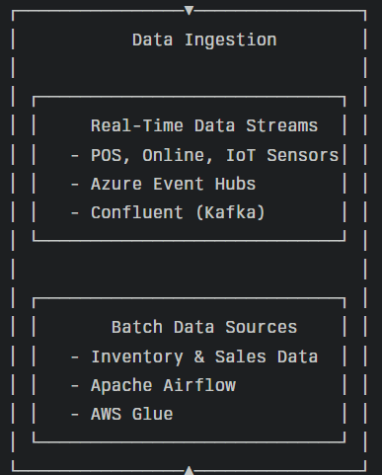 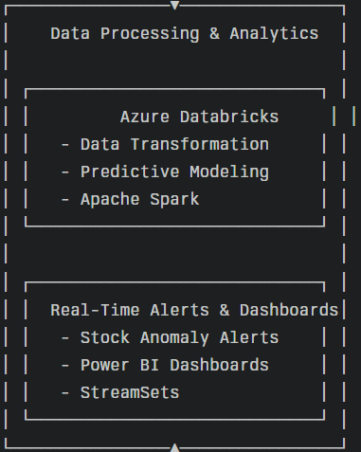 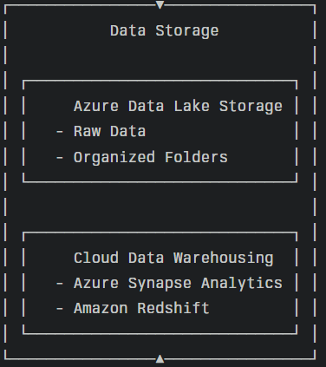

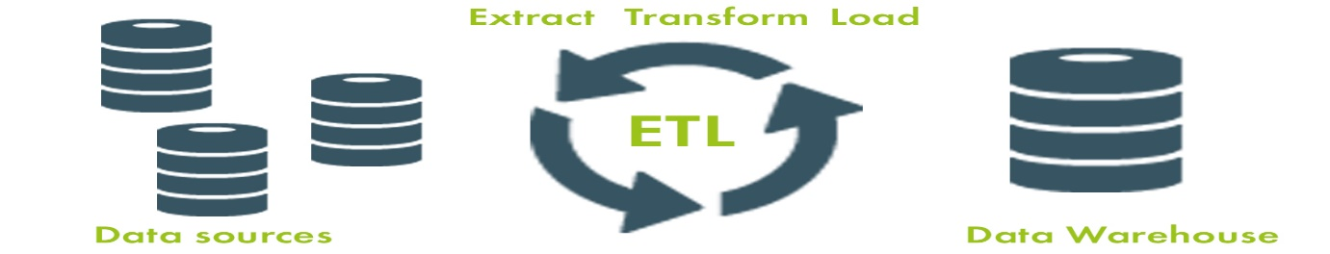

**Cloud Architecture**

**Conclusion**:

1. Dollarama can improve the efficiency, flexibility, and scalability of its data operations by centralising data from multiple sources and utilising cloud-based technology. Dollarama can easily combine data from a variety of sources, including sales transactions, inventory management systems, and customer interactions, thanks to the shared data pipeline. The company will be able to make better decisions as a result of this integration, which has given it a complete understanding of its operations and client behaviour. Furthermore, Dollarama can do real-time analytics on its data thanks to the cloud architecture, which enables the business to spot trends, patterns, and abnormalities right away. With the use of this real-time intelligence, Dollarama will be able to improve customer satisfaction, adjust quickly to changes in the market, and manage inventory levels.
2. Dollarama's decision-making and predictive analytics skills can be greatly improved. With the use of real-time data processing and sophisticated analytics, Dollarama can be better equipped to forecast future trends, consumer behaviour, and inventory requirements. Predictive analytics's capacity to assist Dollarama in making defensible judgements based on insights from data is one of its main advantages. Dollarama can be able to forecast client demand, optimise inventory levels, and customise its product offerings to suit customer demands by examining previous data and market patterns. Furthermore, Dollarama can have the scalability and flexibility required to implement complex predictive analytics models thanks to the cloud architecture. Because of this, Dollarama will be able to react swiftly to shifting market conditions and take prompt action to encourage company expansion.
3. Through the centralization of data and the utilisation of cloud-based technology, Dollarama can achieve unprecedented levels of automation and integration in its operations. Dollarama can reduce its data integration procedures with the common data pipeline, enabling smooth communication between various departments and systems. Dollarama will be able to increase data consistency throughout the company, decrease manual errors, and increase operational efficiency because of this integration. Furthermore, Dollarama will be able to automate a large number of its regular procedures and operations thanks to the cloud architecture. Because of this automation, Dollarama can be able to concentrate on more strategic projects and customer-focused activities, freeing up important time and resources.
4. Through the process of centralising data and utilising cloud-based technology, Dollarama can enhance its data security protocols and expanded its operations to accommodate increasing customer needs. Dollarama can put strong security measures in place to guard its data against unauthorised access through the shared data pipeline, guaranteeing that client and corporate data are kept private and safe. This entails access limits, encryption, and routine security audits to find and fix any weaknesses. Furthermore, Dollarama can have the scalability required to support its expanding business due to the cloud architecture. Due to its flexibility in allocating resources according to demand, Dollarama will be able to swiftly adjust to shifting market conditions and meet growing demands for data processing.
5. Dollarama can significantly influence its resource and expense management plans. Dollarama can manage its resources and expenses more effectively by centralising data and utilising cloud-based solutions. Dollarama can reduce the need for manual intervention and minimised errors in its data management procedures by streamlining them using the shared data pipeline. Because employees can concentrate on more strategic activities, this can improve resource allocation and resulted in cost reductions. Additionally, Dollarama will have the freedom to scale its resources up or down in response to demand thanks to the cloud architecture. Since it will only pay for the resources it uses, Dollarama will be able to better control the costs of its IT infrastructure due to this scalability.